National Parvo Awareness Day 2025
Platform: Facebook, Instagram
Draft Copy: Join us in recognizing the 2nd annual National Parvo Awareness Day and the start of peak parvo season. We are committed to raising awareness of this deadly disease and ensuring that both veterinarians and owners can track canine parvovirus (parvo) outbreaks in their communities using ParvoTrack – powered by Elanco, the first-ever online tracking site for parvo.
Self-report cases and get alerts about local outbreaks by visiting StopParvo.com.
#DefeatParvo
Recommended Image:
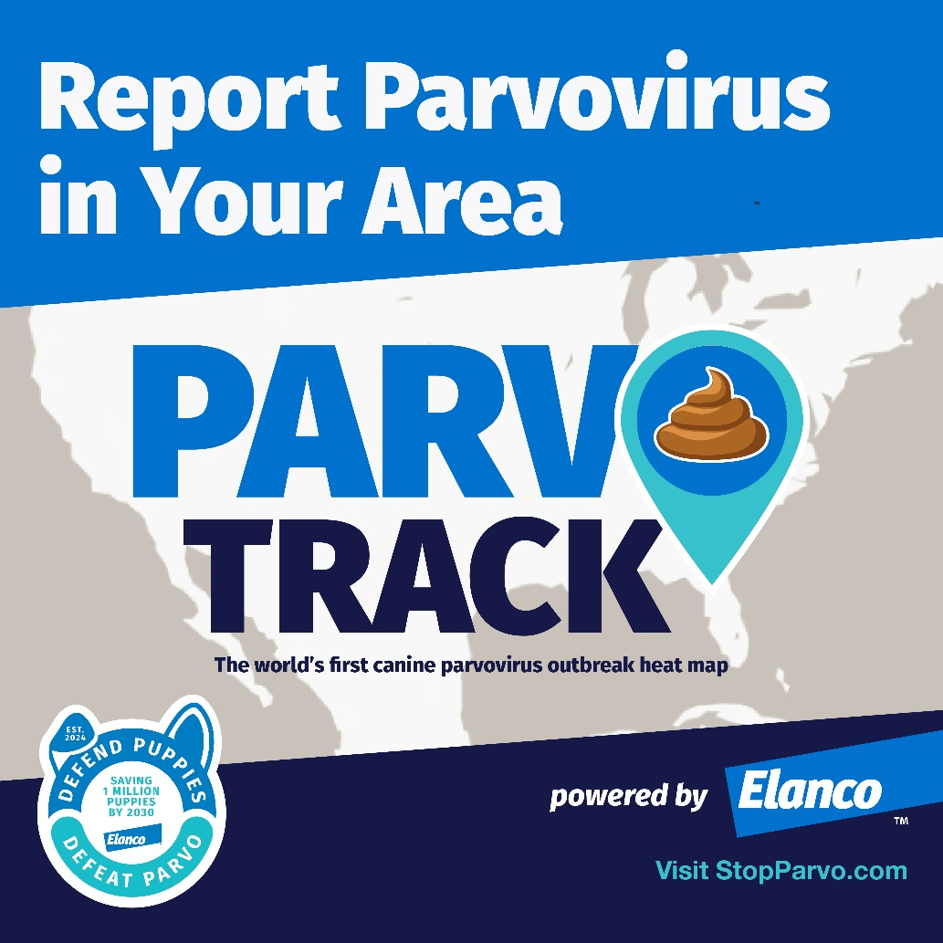

Platform: Instagram, Facebook
Note: Tag @Elanco on Facebook and @Elanco4Pets on Instagram
Draft Copy: Proud to be partnering with @Elanco to recognize National Parvo Awareness Day and raise awareness of this deadly virus. Canine parvovirus (parvo) spreads via feces so it’s important for pet owners to learn the signs, symptoms and breakthrough solutions to treat parvo.
Learn more about treatment options and sign up for local alerts at StopParvo.com.
#DefeatParvo
Recommended Images:
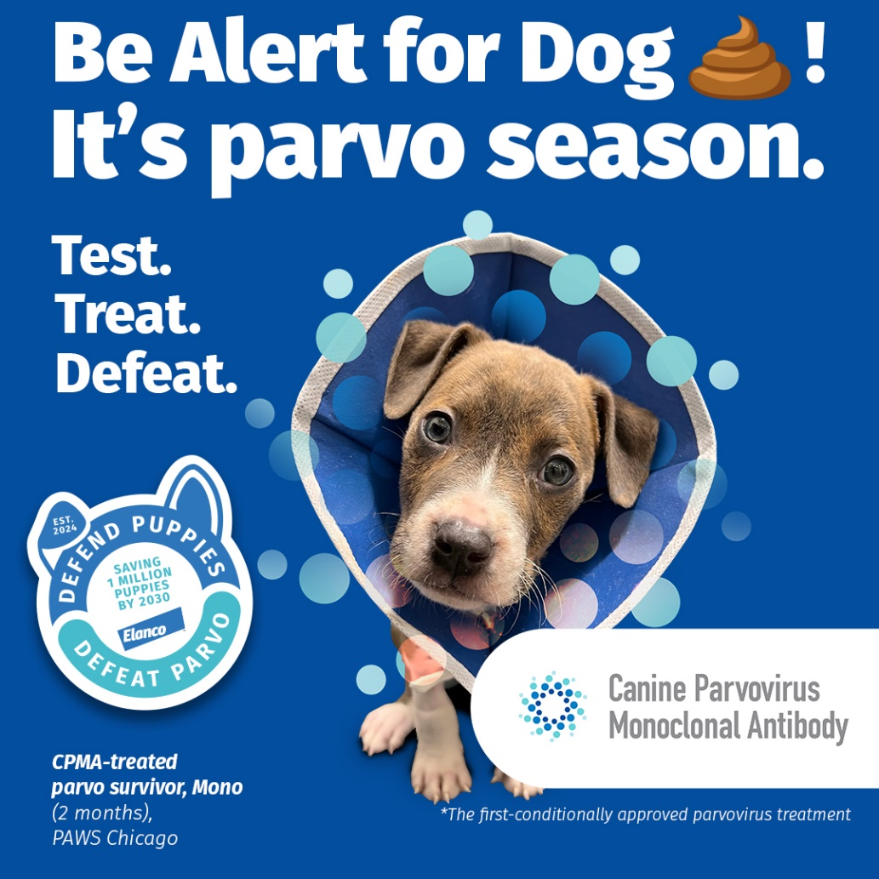
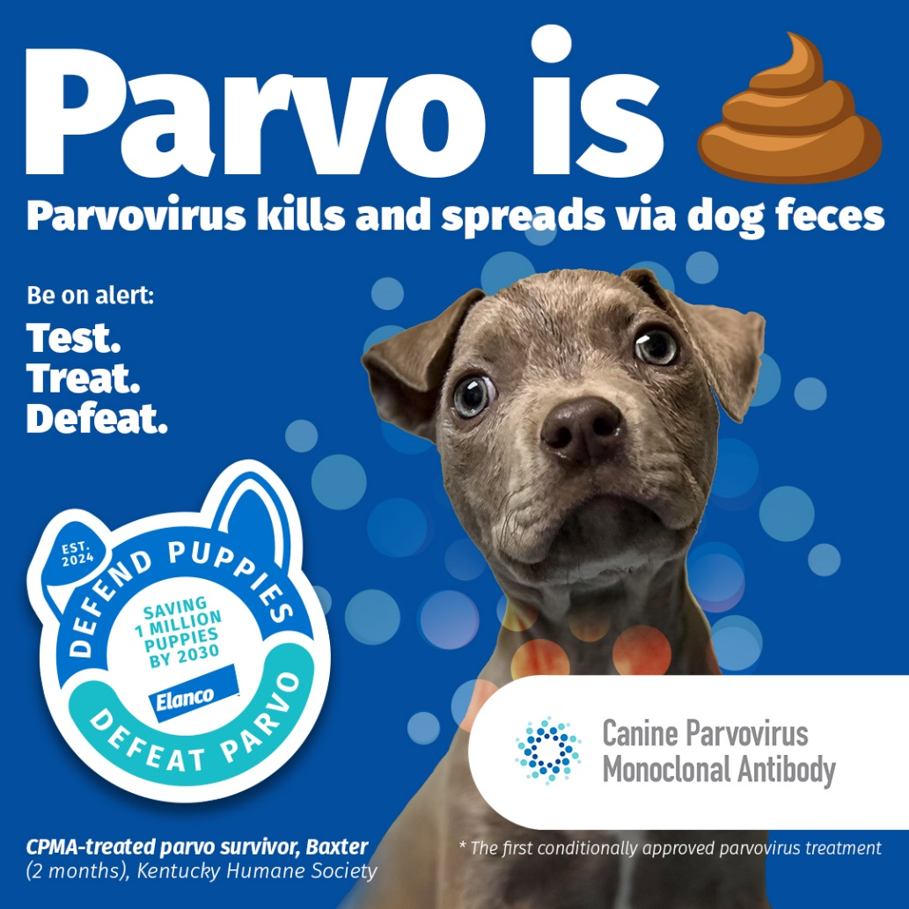
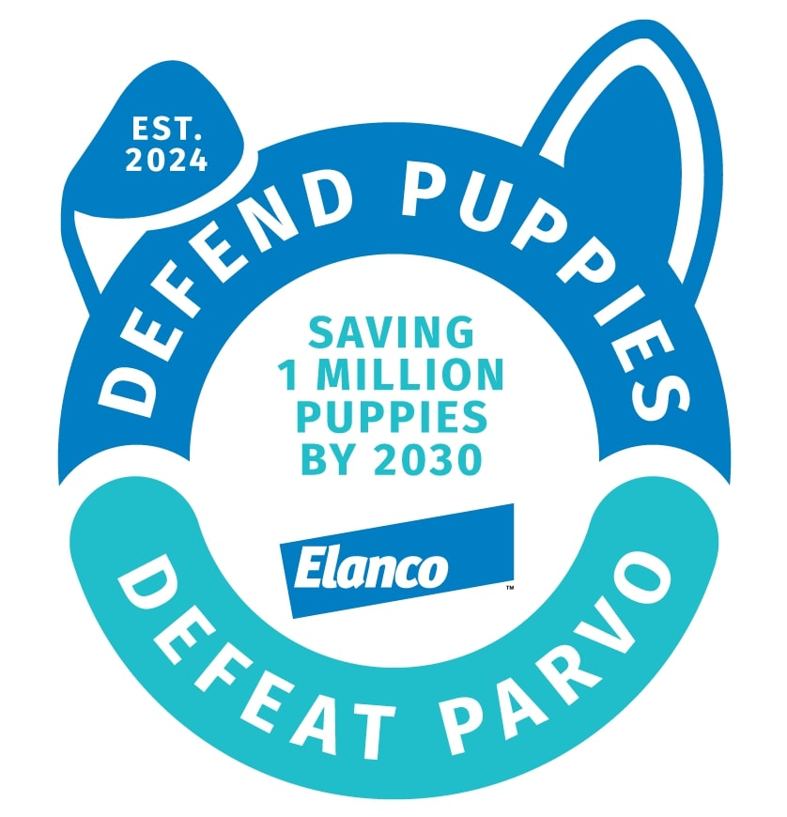
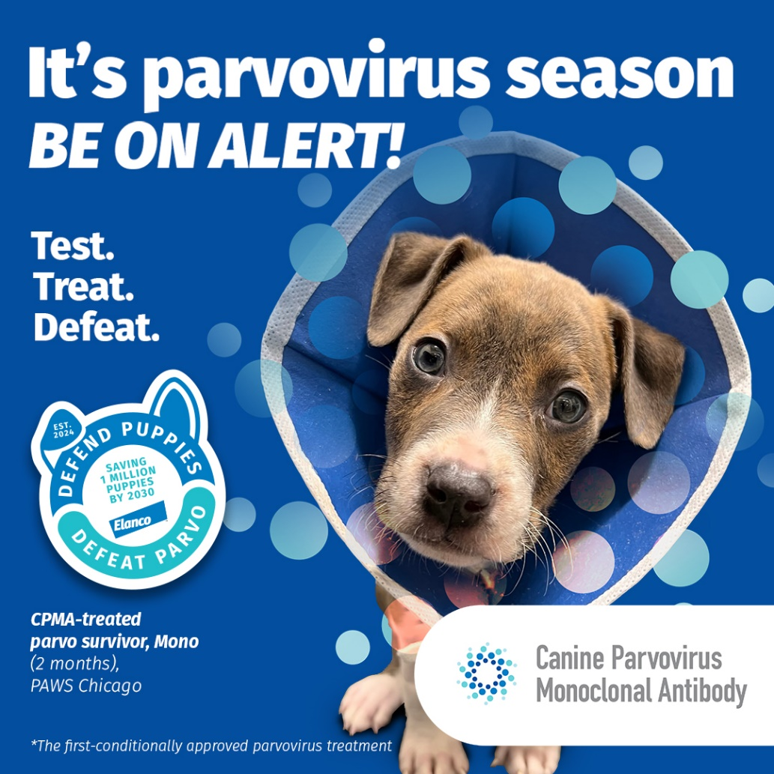
Platform: Instagram, Facebook
Suggested Copy:
Share the story + image of a parvo survivor from your clinic in honor of National Parvo Awareness Day and the start of peak parvo season!
Recommended Image:
Parvo survivor from your clinic!

